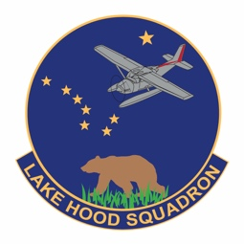
LAKE HOOD CADET SQUADRON
CIVIL AIR PATROL
UNITED STATES AIR FORCE AUXILIARY
Anchorage, AK 99502

DD Mmmmm YYYY

Grade Sender's Name, CAP
Sender's Unit
Civil Air Patrol

Receiver's Title and Full Name
Receiver's Company (optional)
Street Address or PO Box
City ST XXXXX-XXXX

Dear Title and Last Name, Sir/Ma'am, or Position

Enter text for first paragraph. Paragraphs are indented 5 spaces or 1/4 inch tab. Paragraphs are not numbered.

Enter contents of subsequent paragraphs using same format.

Closing paragraph should summarize desired action (if any) and provide contact information for the business style letter's point of contact (if other than the sender).

Sincerely

SENDER'S NAME, Grade, CAP
Duty Title

"Attachment:" for one item or "# Attachments:" for more than one
List numbered attachment(s) mentioned in letter, do not number if only one.

