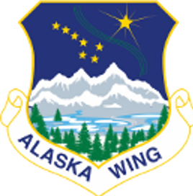
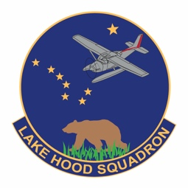
LAKE HOOD CADET SQUADRON
CIVIL AIR PATROL
UNITED STATES AIR FORCE AUXILIARY
6661 Round Tree Dr.
Anchorage, AK 99507

23 July 2020

Cadet Captain Alan Padgett, CAP
Cadet Commander
Lake Hood Cadet Squadron
Civil Air Patrol

Northern Smiles Orthodontics
2000 Abbott Rd, Unit 202
Anchorage, AK 99507

Dear Sir/Ma’am,

My brother Ryan and I got our braces at Northern Smiles and noticed that Northern Smiles donates money to different groups in Anchorage. We have both been very active in the Civil Air Patrol for the last 2 ½ years (since we were 12 and 14) and wonder if you could help our squadron.

Lake Hood Squadron has 30 cadets (teenagers) from all over Anchorage. We meet weekly (virtually during COVID) and learn about and practice leadership, STEM topics, search and rescue, character development, physical fitness, and other topics that get us ready for life after high school. As a civilian auxiliary of the US Air Force, you can imagine that most cadets’ favorite STEM topic is aviation!

Any donation you make helps cover cadets’ expenses for flight instruction, uniforms, and travel to other towns in Alaska and the Lower 48 for specialized training in aviation, leadership, cybersecurity, and search and rescue. The Air Force pays some of the costs but not all.

Please consider donating any amount you like. $250 covers an average year of expenses for an active cadet. $1000 would cover expenses for 4 cadets. For $500 or more, we can list Northern Smiles Orthodontics as one of our sponsors for the next year on our website, https://lakehood.cap.gov/

Thank you very much for your consideration of our request!

Sincerely

ALAN PADGETT, C/CAPT, CAP
Cadet Commander

